You are receiving this email as a member of the media.
If you wish to unsubscribe from future messages, please reply with UNSUBSCRIBE in the subject line.

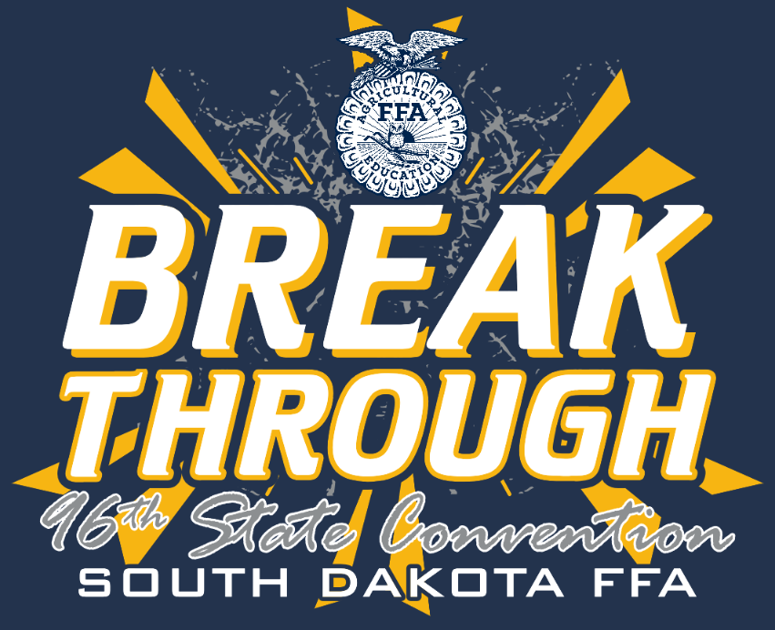
NEWS RELEASE

South Dakota FFA Association
Website: www.sdaged.org
Facebook: www.facebook.com/South.Dakota.FFA
Instagram: @sdffaassociation
For more information, contact:
Caroline Hanson
South Dakota Leadership and Program Manager
Caroline.hanson@sdaged.org

Gerri Eide
SD FFA Foundation Executive Director
Gerri@sdffafoundation.org

FOR IMMEDIATE RELEASE
April 21, 2024

Agriscience Fair photos available to download at: https://drive.google.com/drive/folders/1aojiI_TLlzVJEO4_erWlrlb3dTzaGOy1?usp=drive_link
All photos are 1-3rd place, left to right.
South Dakota FFA Agri-Scientists Recognized
BROOKINGS, S.D. –Students received finalist FFA AgriScience Distinction during this week’s State FFA Convention. The SD FFA Association recognizes students who gain real-world, hands-on experiences in agricultural enterprises.

Agriscience students use scientific principles and emerging technologies to solve complex problems related to agriculture, food and natural resources in six different categories (Animal Systems; Environmental and Natural Resource Systems; Food Products & Processing Systems; Plant Systems; Power, Structural & Technology Systems; Social Systems). Projects involve extensive research as well as writing a written report including information on previous studies related to the topic, their research and findings. Students can compete in the AgriScience Fair as an individual or with a team in separate divisions:
I – Individual member in grades 7 and 8
II – Team of two members in grades 7 and 8
III – Individual member in grades 9 and 10
IV – Team of two members in grades 9 and 10
V – Individual member in grades 11 and 12
VI – Team of two members in grades 11 and 12

The top projects in each division will advance for a chance to compete at the National FFA Agriscience Fair at the National Convention in Indianapolis, Indiana this fall. The winners are as follows:

Animal Systems
The study of animal systems, including life processes, health, nutrition, genetics, management and processing, through the study of small animals, aquaculture, livestock, dairy, horses, and/or poultry.
Division 1, sponsored by Eichacker Simmentals, Salem Veterinary Service, Dakota Hills Veterinary Clinic and DeTye Vet Supply:
1st – Charlie Cody, Tri-Valley
2nd – Alexis Schock, McCook Central
3rd – Isaac Robert, McCook Central
Division 2, sponsored by Eichacker Simmentals, Salem Veterinary Service, Dakota Hills Veterinary Clinic and DeTye Vet Supply:
Sponsor: Mike Stiefvater, Salem, Veterinary Services
1st – Steele Anglin & William Winter, Tri-Valley
2nd – Bree Smart & Sophie Sandine, McCook Central
3rd – Chanel Mohrhauser & Alli Foremna, Tri-Valley
Division 3, sponsored by Fall River Feedyard and the Franken Family:
1st – Alex Siemonsma, West Central
2nd – Gabby Hanson, Sisseton
3rd – Caedon Gates, West Central
Division 4, sponsored by Fall River Feedyard and the Franken Family:
1st – Nate Struck & Noah Erickson, West Central
2nd – Gracie Pedersen & Isabella Mack, Tri-Valley
3rd – Austin Michaels & Hunter Wagner, West Central
Division 5, sponsored by Dakota Hills Veterinary Clinic, Fall River Veterinary Clinic, Buffalo Ranch Supply and First Dakota National Bank:
Sponsor: Kevin Blagg, First Dakota National Bank
1st – Kelsey Vockrodt, West Central
2nd – Emma Schneider, Dolan
3rd – Brooklyn Beringer, Gettysburg
Division 6, sponsored by Dakota Hills Veterinary Clinic, Fall River Veterinary Clinic, Buffalo Ranch Supply and First Dakota National Bank:
Sponsor: Kevin Blagg, First Dakota National Bank
1st – Kolten Stiefvater & Karlie Stiefvater, McCook Central
2nd – Joseph Grady & Julianne Grady, McCook Central
3rd – Lucas Ebbinga & Jett Whiting, West Central

Environmental Service/Natural Resource Systems
The study of systems, instruments and technology used in waste management; the study of the management of soil, water, wildlife, forests and air as natural resources and their influence on the environment.
Division 1, sponsored by Ducks Unlimited:
1st – Emerri Gottlob, McCook Central
2nd – Khloie Klinkhammer, McCook Central
3rd – Thomas Oyen, McCook Central
Division 2, sponsored by Ducks Unlimited:
1st – Brenna Bartlett & Claire Vogel, Montrose
2nd- Joseph Kayser & Creighton Werning, Bridgewater Emery
3rd – Taygen VanDerVliet & Colt Johnson, Buffalo Christian
Division 3, sponsored by Macksteel Farm and Ranch Equipment, Dry Creek Farm & Ranch and the Pennington County Conservation District and Farm Credit Services of America:
Sponsor: Brain Gottlob, Farm Credit Services of America
1st – Noah Felderman, Doland
2nd – Luke Horstman, McCook Central
3rd – Olivia Knox, Doland
Division 4, sponsored by Macksteel Farm and Ranch Equipment, Dry Creek Farm & Ranch and the Pennington County Conservation District and Farm Credit Services of America:
Sponsor: Brain Gottlob, Farm Credit Services of America
1st – Jace Wager & Sage Hermann, Gettysburg
2nd – Theodore Peterson & Gunnar Alfson, West Central
3rd – Corven Johnson & Logan Kenyon, Tri- Valley
Division 5, sponsored by ProAg Engineering, Inc.:
1st – Jude Jarding, West Central
2nd – Samantha Geffre, Leola
3rd—Tyanne Osterkamp, Northwestern Area
Division 6, sponsored by ProAg Engineering, Inc.:
1st – Harlee Nielson & Mikael Nielson, Hitchcock-Tulare
2nd – Emery Pearson & Corie Wicks, Tri-Valley
3rd – Carter Evans & Easton Eberhard, West Central

Food Products and Processing Systems
The study of product development, quality assurance, food safety, production, sales and service, regulation and compliance and food service within the food science industry.
Division 1, sponsored by the South Dakota Retailers Assocation, Brian and Codi Mills, Doland FFA:
Sponsor: LeAnne Bawek, Doland FFA
1st – Stells Oyen, McCook Central
2nd – Tessa Burke, Bridgewater Emery
3rd – Brodie Boomsma, Doland
Division 2, sponsored by the South Dakota Retailers Assocation, Brian and Codi Mills, Doland FFA:
1st – Josalyn Traupel & Leah Feterl, McCook Central
2nd – Iliana Krusinger & Olivia Havard, McCook Central
Division 3, sponsored by the South Dakota Retailers Association and the Doland FFA Alumni:
1st – Kenasyn Johnson, West Central
2nd – Addison Ecklein, McCook Central
3rd – Kendall McAreavery, Tri-Valley
Division 4, sponsored by the South Dakota Retailers Association and the Doland FFA Alumni:
Sponsor: LeAnne Bawek, Doland FFA Alumni
1st – Mattie Huwe & Ava Christensen, Tri-Valley
2nd – Lauren Jones & Kamryn Schaaf, West Central
3rd – Brooklyn Roberts & Stella Siemonsma, West Central
Division 5, sponsored by Jim Chilson, Grain Millers Inc., McCook Central FFA, Carl & Kari Sanders:
1st – Courtney Decker, Northwestern Area
Division 6, sponsored by Jim Chilson, Grain Millers Inc., McCook Central FFA, Carl & Kari Sanders:
1st – Zoe Dissing & McKenzie Mack, Tri-Valley
2nd – Collin Shellum & Jakob Gnadt, Garretson
3rd – Kaizha Blase & Isabela Jimenez, McCook Central

Plant Systems
The study of plant life cycles, classifications, functions, structures, reproduction, media and nutrients, as well as growth and cultural practices, through the study of crops, turf grass, trees and shrubs and/or ornamental plants.
Division 1, sponsored by Next Level Ag, Dan & Sheri Kahnke, Bayer, SD Corn Utilization Council:
1st – Jack Remily, Doland, (pictured Layne Andrews, Beresford)
2nd – Adeline Miles, McCook Central
3rd – Hudson Hansen, Doland
Division 2, sponsored by Next Level Ag, Dan & Sheri Kahnke, Bayer, SD Corn Utilization Council:
1st – Isaac Chase & Cale Hoffman, McCook Central
2nd – Connor Heiberger & Noah Durfee, McCook Central
3rd – Josephine Weihe & Jayden Jasper. Montrose
Division 3, sponsored by Dan & Sheri Kahnke, Central Farmers Cooperative, The First National Bank of Sioux Falls:
1st – Alexa Pulse, McCook Central
2nd – Eva Healy, West Central
3rd – Ty Boekelheide, Northwestern Area
Division 4, sponsored by Dan & Sheri Kahnke, Central Farmers Cooperative, The First National Bank of Sioux Falls:
1st – Ayla Kramer & Taylor Borgen, West Central
2nd – Danielle Wipf & Brunn Barney, Tri- Valley
3rd – Emily Wenzel & Brody Thompson, Tri-Valley
Division 5, sponsored by the SD Soybean Research & Promotion Council:
1st – Tanner Eide, Gettysburg
2nd – Tyler Groenewold, Tri-Valley
3rd – Emily Watson, Harrisburg
Division 6, sponsored by SD Soybean Research & Promotion Council:
1st – Ireland McAreavey & Corral Benson, Tri-Valley
2nd – Cooper Mulder & Bryce Ridings, West Central

Power, Structural, and Technical Systems
The study of agricultural equipment, power systems, alternative fuel sources and precision technology, as well as woodworking, metalworking, welding, and project planning for agricultural structures.
Division 1, sponsored by Meyerink Farm Service:
1st – Joseph VanEmmerick, McCook Central
2nd – Taylor Hawley, Bridgewater Emery
3rd – Ayden Kuhl, McCook Central
Division 2, sponsored by Meyerink Farm Service:
1st – Beau Hiernonimus & Bentley McMillen, Tri-Valley
2nd – Jackson Pedersen & Ari Loen, Tri-Valley
3rd – Hunter Thompson & Kyle Barenklau, Montrose
Division 3, sponsored by Butler Machinery and CTE Global, Inc:
Sponsor: Courtney Ireland & Alethea Caraway, CTE Global, Inc.
1st – Tucker Peterson, McCook Central
2nd – Carson Ewalt, Northwestern Area
3rd – Austin Nash, Northwestern Area
Division 4, sponsored by Butler Machinery and CTE Global, Inc:
Sponsor: Courtney Ireland & Alethea Caraway, CTE Global, Inc.
1st – Gage Egger & Ty Oyen, Tri-Valley
2nd – Gavin Crosby & Chase Jones, Tri-Valley
3rd – Briggs LaBrie & Logan LaBrie, Doland (not pictured)
Division 5, sponsored by Dacotah Bank, Summit Contracting, RDO Equipment, Gullickson Family Livestock:
Sponsor: Haley Borszich, Dacotah Bank; Jason Peterson & Matt Milosevich, RDO Equipment
1st- Reece Gerlach, West Central
2nd – James Bame, Madison Central
Division 6, sponsored by Dacotah Bank, Summit Contracting, RDO Equipment, Gullickson Family Livestock:
Sponsor: Haley Borszich, Dacotah Bank; Jason Peterson & Matt Milosevich, RDO Equipment; Mike Berg & Nate Moe, Summit Contracting
1st – Lexi Nichols & Sydney Neel, West Central
2nd – Brea Janes & McKenzie Dow, Tri-Valley
3rd – Sam Carlson & Alexis Weinacht, Tri-Valley

Social Science
The study of human behavior and the interaction of individuals in and to society, including agricultural education, agribusiness economics, agricultural communications, agricultural leadership and other social science applications in agriculture, food, and natural resources.
Division 1, sponsored by Chad Wosje (in photo):
1st – Hadley Flogstad, McCook Central
2nd – Hailey Heumiller, McCook Central
3rd – Benjamin Bergeson, MCCook Central
Division 2, sponsored by Chad Wosje (in photo):
1st – Jaxon Scheff & Mason Casilli, Montrose
2nd – Andrew Sabers & Liam Rayman, McCook Central
Division 3, sponsored by Prairie Grain Partners, LLC., Sd Biotech Association:
1st – Bobbi Eide, Gettysburg
2nd – Atlee Olson, Belle Fourche
3rd – Elle Goehring, Parkston
Division 4, sponsored by Prairie Grain Partners, LLC., Sd Biotech Association:
1st – Nora Gordon & Paislee Lindstrom. Montrose
2nd – Holly Berg & Ashtyn Nilson, West Central
3rd – Karlee Klinkhammer & Avery Alley. McCook Central
Division 5, sponsored by Farmers Mutual of Nebraska, Pioneer-Corteva and BankWest:
1st – Lane Duetsch, McCook Central
2nd – Reganne Miles, Doland
3rd – Renee Uberty, McCook Central
Division 6, sponsored by Farmers Mutual of Nebraska, Pioneer-Corteva and BankWest:
1st- Lauren Roling & Alyssa Roling, McCook Central
2nd – Abby Chase & Ava Sieverding, McCook Central
3rd – Espn Althoff & Bracken Sharpe, Tri-Valley
About the South Dakota FFA Association: The National FFA Organization is a national youth organization of 850,823 student members as part of 8,995 local FFA chapters in all 50 states, Puerto Rico and the Virgin Islands. As part of the National FFA Organization, the South Dakota FFA Association encompasses 109 chapters with over 5,000 South Dakota FFA members. FFA strives to make a positive difference in the lives of students by developing their potential for premier leadership, personal growth and career success through agricultural education. To discover more about the South Dakota FFA Association or the South Dakota FFA Foundation, visit them both at sdaged.org or on Facebook and Instagram.

-###-

